**NAME: SAVEETHA SCHOOL OF ENGINEERING**

**SAVEETHA INSTITUTE OF MEDICAL AND TECHNICAL SCIENCES**

**INSTITUTE OF PLACEMENT AND TRAINING**

**CSA0987 –JAVA PROGRAMMING**

**NAME:N.Charan Sai**

**REG.NO:192372003**

**LEVEL-1-TEST**

**1.EVEN SUM FIB**

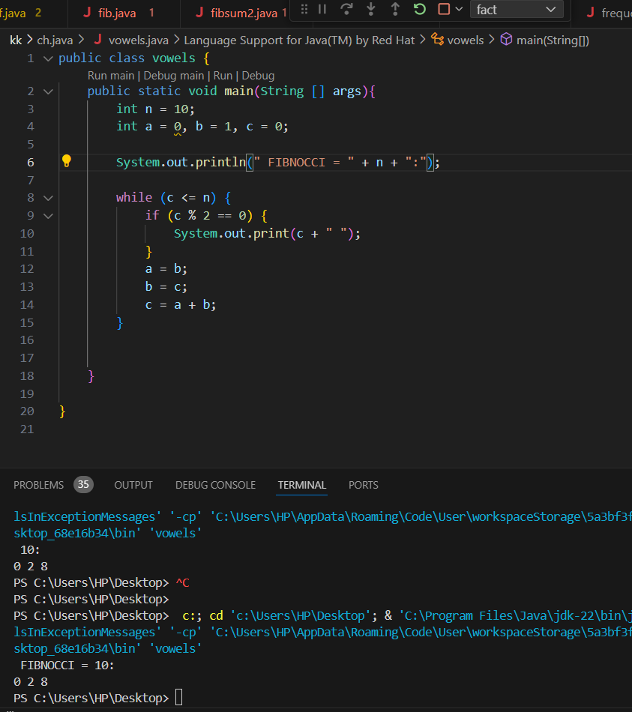

2.WRITE A PROGRAM FOR COMPOSITE NUMBERS B/W A AND B.

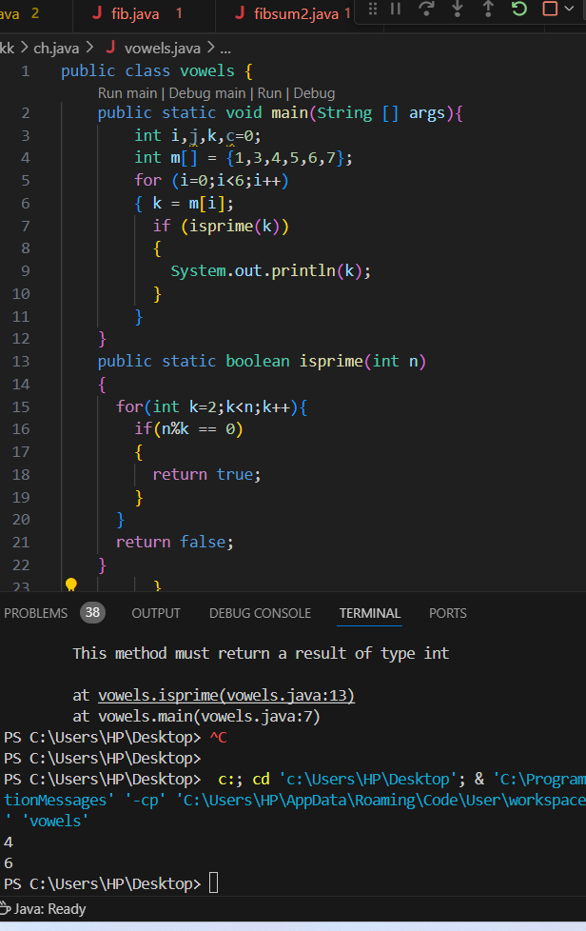

3.WRITE A PROGRAM FOR NO.OF FACTORS IN GIVEN NUMBER.

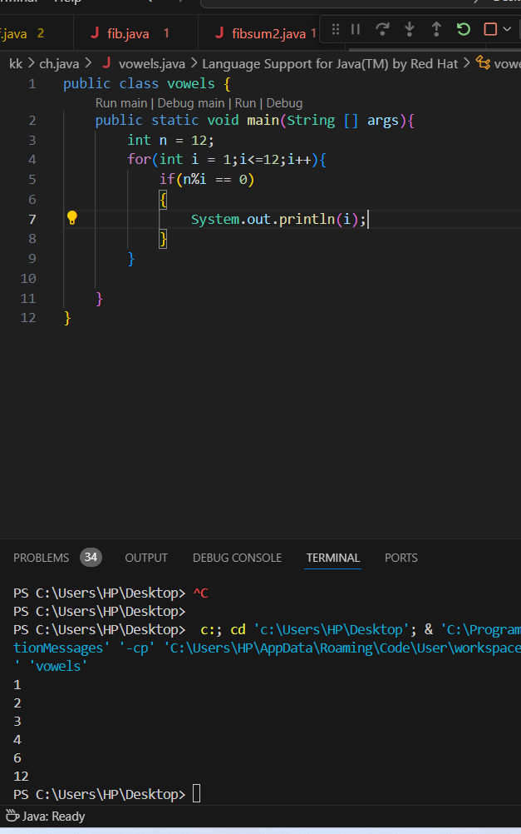

4. WRITE A PROGRAM FOR REVERSE A NUMBER USING LOOPS.

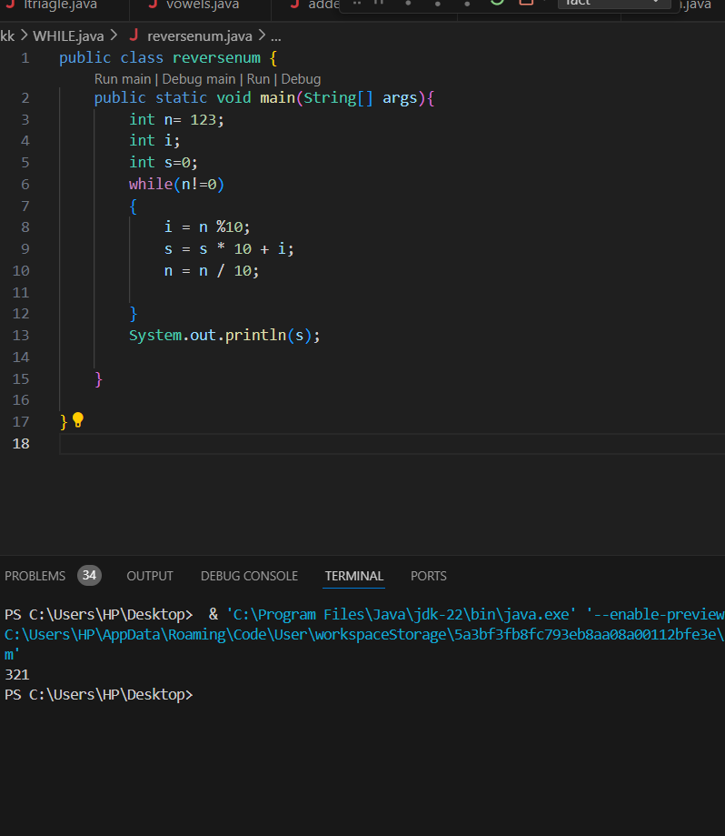

5. WRITE A PROGRAM FOR MARTIX MULTIPLICATIONS(3*3).

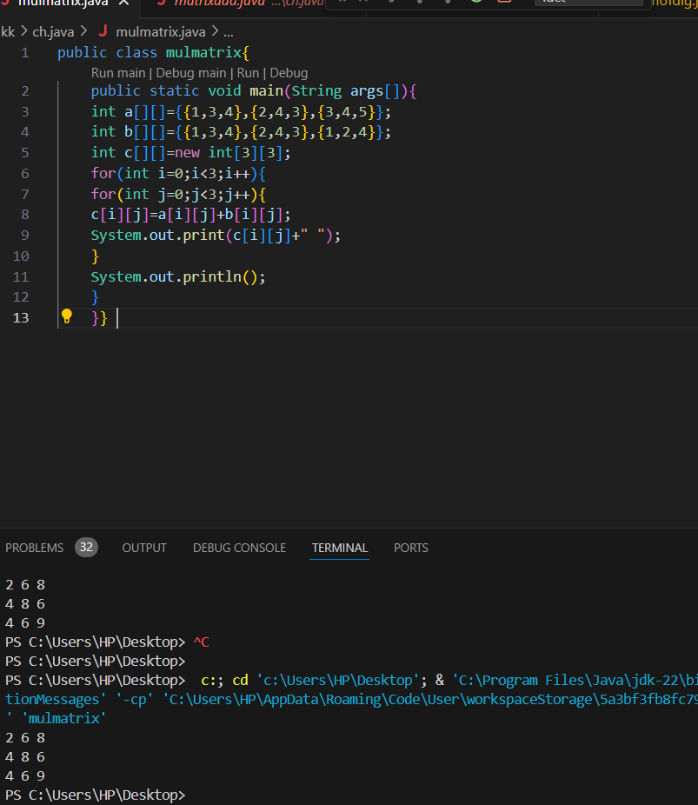

6.MEAN MEDIAN

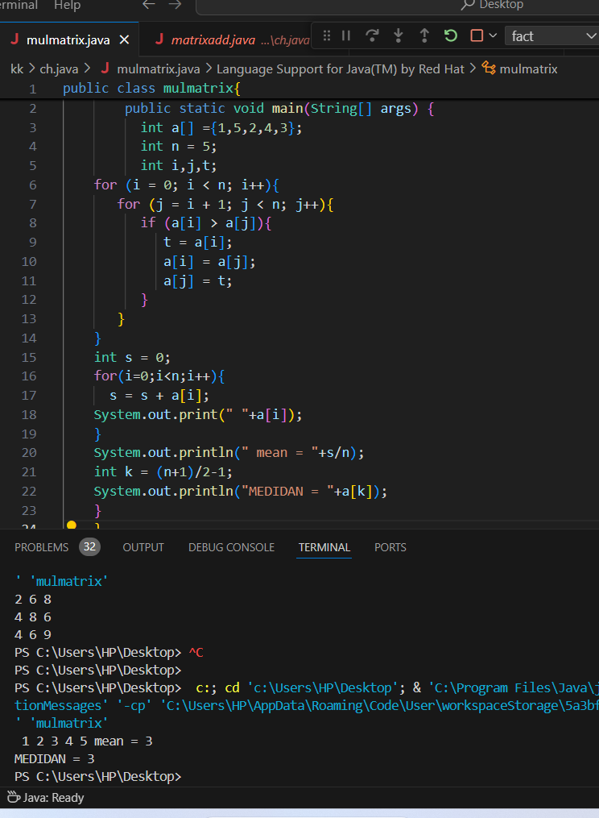

7. WRITE A PROGRAM FOR RIGHT ANGLED STAR PATTERN

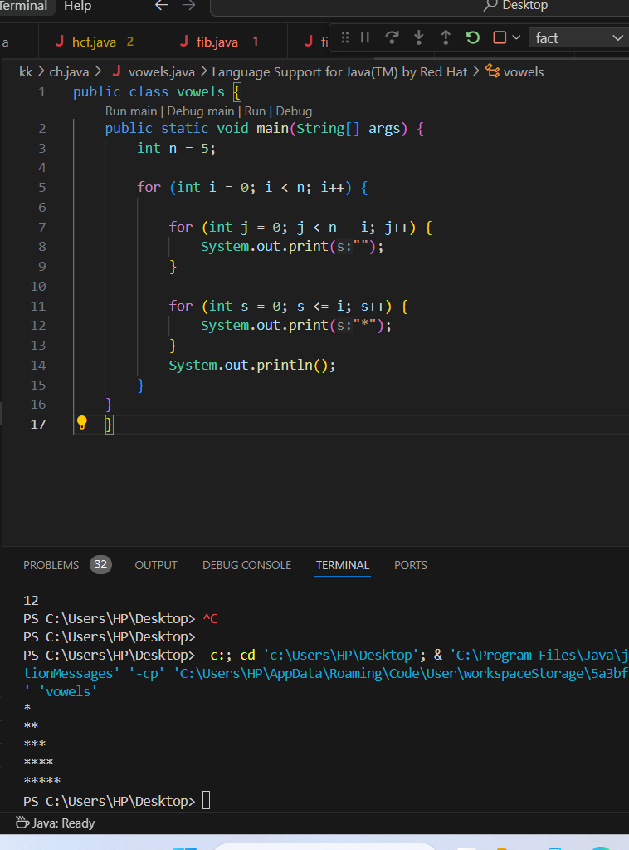

8.WRITE A PROGRAM FOR INVERTED PYRAMID IN PATTERN

